**Create the K8s EKS, further have to do the deployment of Nginx application**

Installing the EKSCTL:



Installing the KUBECTL:

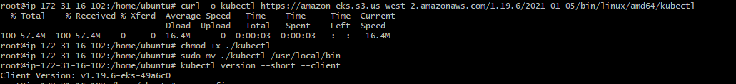

AWS CLI Installation and Configuration:

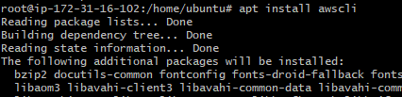

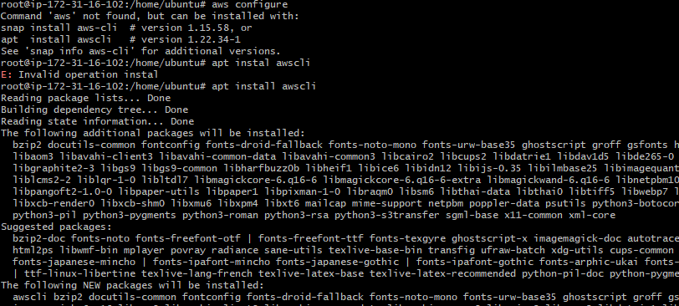

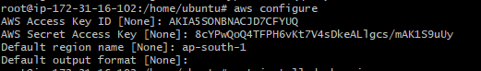

Docker Installation:

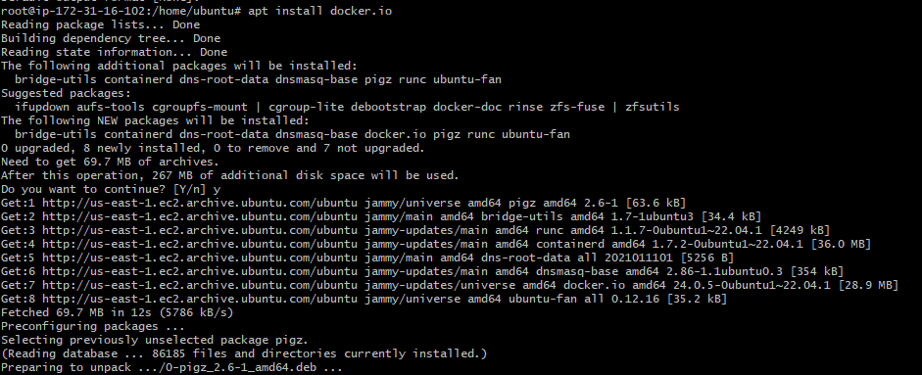

EKS Cluster creation with nodes

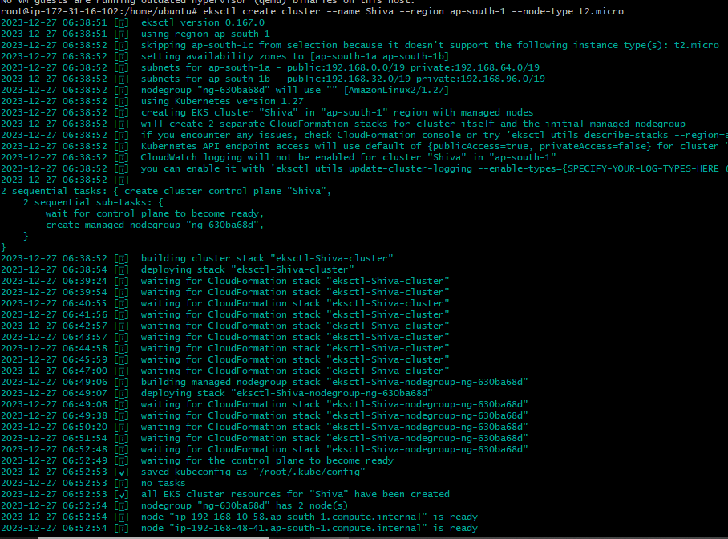

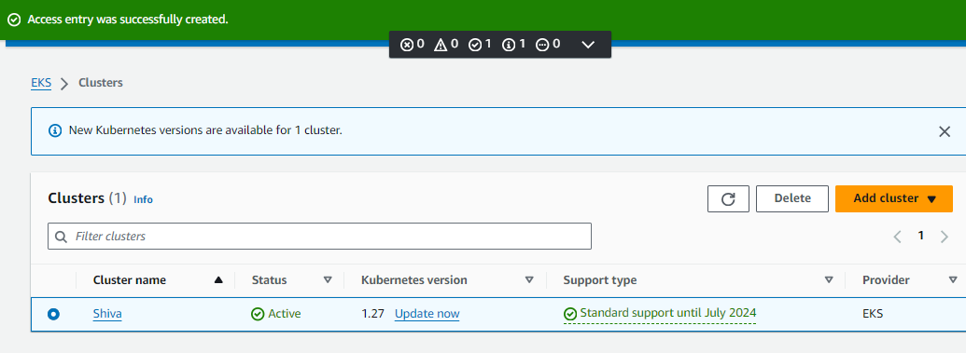

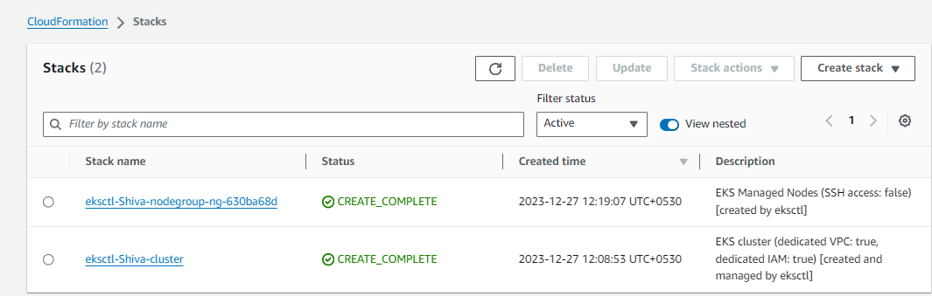

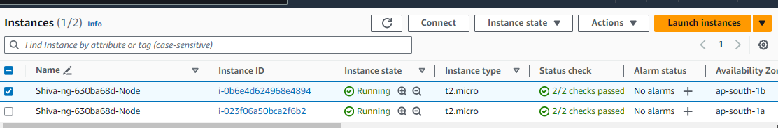

Verifying the nodes in CLI



**Deploying the Nginx Application:**

kubectl create deployment nginx --image=nginx

kubectl expose deployment nginx --type=NodePort --port=80

